2)what is nodejs

Nodejs is js runtime. What does it mean? We use js to manipulate dom in browser. But js is not limited to that. Nodejs is different version of js you could say. It is basically built on js , it adds some fetaures to it, it is not capable of doing some other things that you can do with js in browser. So it takes js and outs it into different environment. it allows you to run js on server, you could say. In theory not on server but on any machine you could say. So it basically allows you to run js not in browser but anywhere else like normal programming language. Core take away is it allows us to run js outside browser.

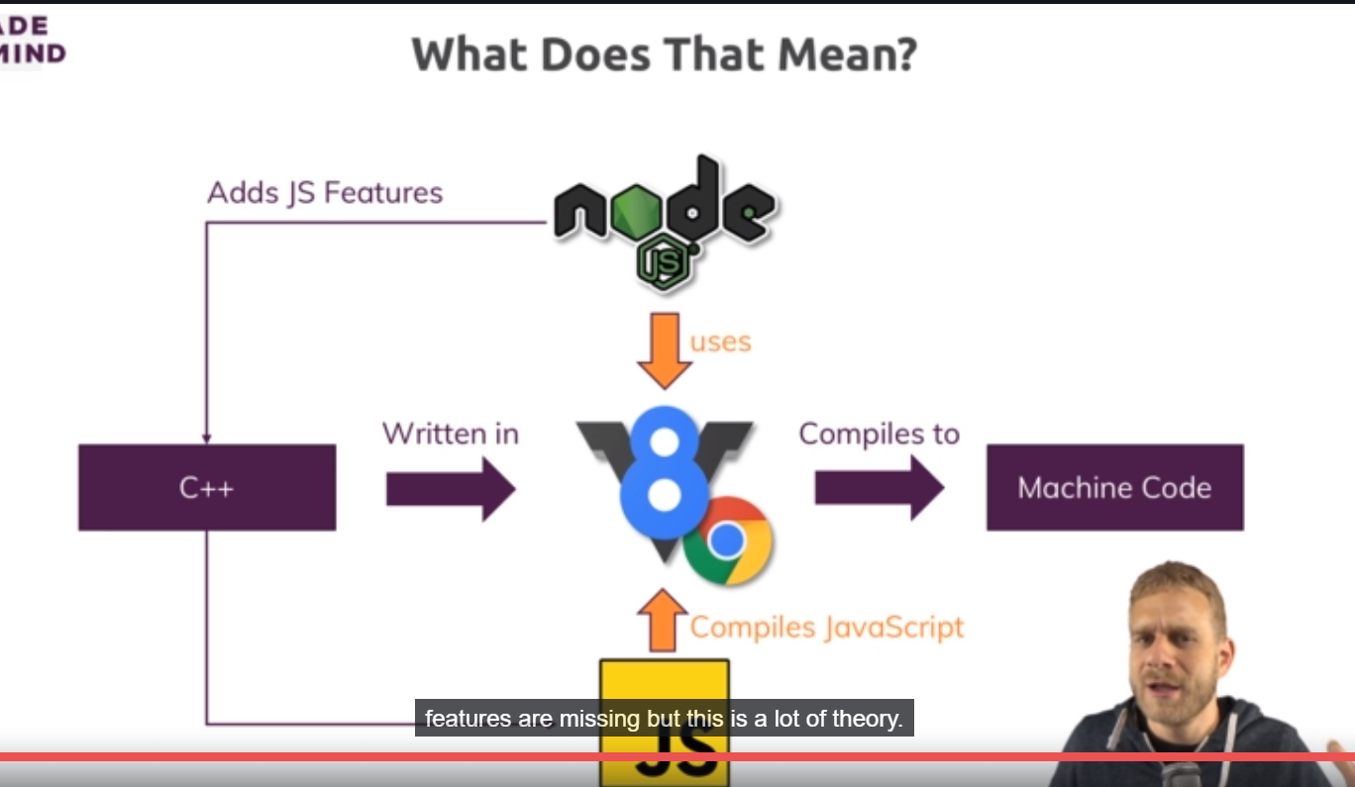

How does it work technically. nodejs uses v8, and v8 is simply name of js engine built by google that runs js in browser. What does an engine mean? Well it simply means that engine takes js code, the code running in your browser or in node’s case(which builds up on it) also the node js javascript code, it takes that code and compiles it to machine code. So that is what v8 does in your browser so that machine code runs finally on computer and runs efficiently. Now this is done by v8, v8 itself is written in c++. That does not matter to you, you do need to write c++ code to use js or nodejs. So nodejs basically takes that v8 code base that is written in c++ and add certain features like for example working with local file system, opening, creating and deleting files. These are things not possible in browser. You cannot access your local file system in browser for security reasons. Nodejs adds these features to v8 engine, you could say. Now nodejs does not run in browser, so these restrictions still apply. There you use vanilla v8, the v8 only without nodejs extension but if you then install nodejs, you can use it to basically use that extended v8 version to run js scripts on your computer which then certainly can access these new features because they dnt run in browser but are directly executed through nodejs runtime you could say. So this is what nodejs does, it allows you to run js on computer , adds some features to make it more useful. It also takes away some features like in browser we can access the dom, outside browser there is no dom, so these features are missing.

3)First app

const fs = require('fs');

fs.writeFileSync('hello.txt', 'Hello from Node.js');

this will create a new file and put a sting in it.

4)Understanding the role and useage of nodejs

We do input validations on server because browser can be tricked. Users can even edit there browser side code. You can open dev tools and start working on page you are on. But server is sheltered from that, user cnt cnt access it. And in general we have our business logic on server, everything our used should’nt see ,which takes too much time to run in browser, well we obviously want to deliver a fast user experience or anything of that kind, that is where we use nodejs.

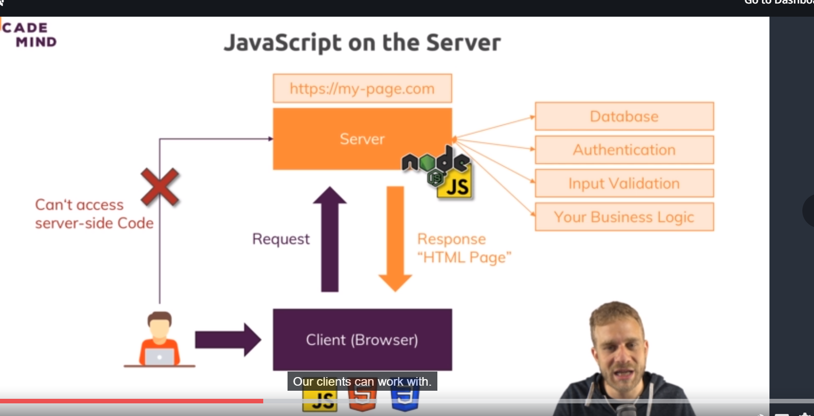

So this is indeirectly how we allow our user to work with the server with request response pattern. Direct access is not avalaible.

Nodejs is not limited to running js code on server only. It’s a js runtime, you saw in first demo where we did;nt do anything which will use browser. We did’nt spin up the server. We didn’t do anything which we would have reached through a browser. So node js in js runtime. We can execute any js code with it. We can use nodejs for **local utility scripts and build tools**. In js frameworks(like angular, react,vue) we use nodejs for build process these framework needs. Because nodejs is great tool for writing utility scripts, you have access to file system. I will dive into section where we see non sever side useage of node. In general and that is most popular thing you do with nodejs though, you use it in context of web develeopemnt and server side code. You use it to run a server and actually that is an important difference to php, for example with nodejs you don’t just write code that is running on server, you also write server yourself. So the code that takes the incoming request and routes them to your other code. In php you have extra tools like apache which run servers, which listen to incoming requests and then execute your php code. Here nodrjs do both. It does listening and also does whatever you do in your code.

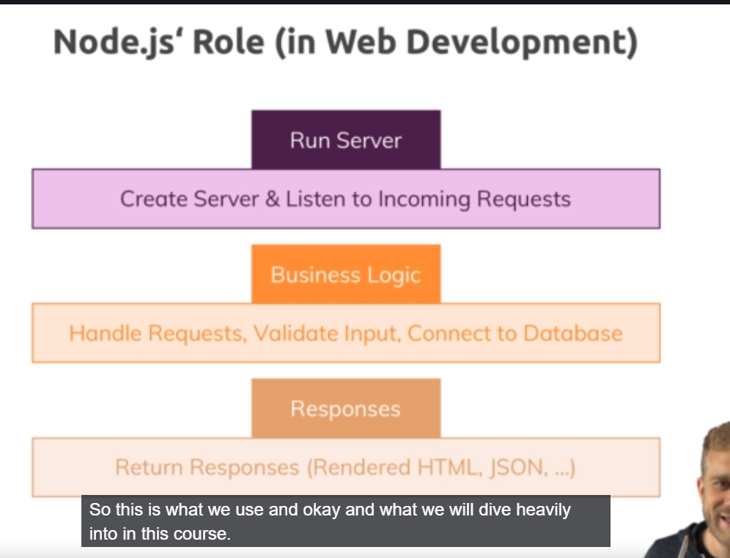

Replacements of node can be python, php, .net etc. there is no clear winner. These languages are capable of doing same kind of stuff and of course they differ in some technical regrads but in general its great to have that broad variety. One huge advantage of nodejs is that it uses js, language that you need so much in modern web development, for all front end, for all build tools and then if you can also use it on server side then you dnt need to use bunch of different languages. Its highly performant and popular language also. in genera nodejs is great solution, its trending, its fast and effiecint.

7)Working with REPL vs Using File

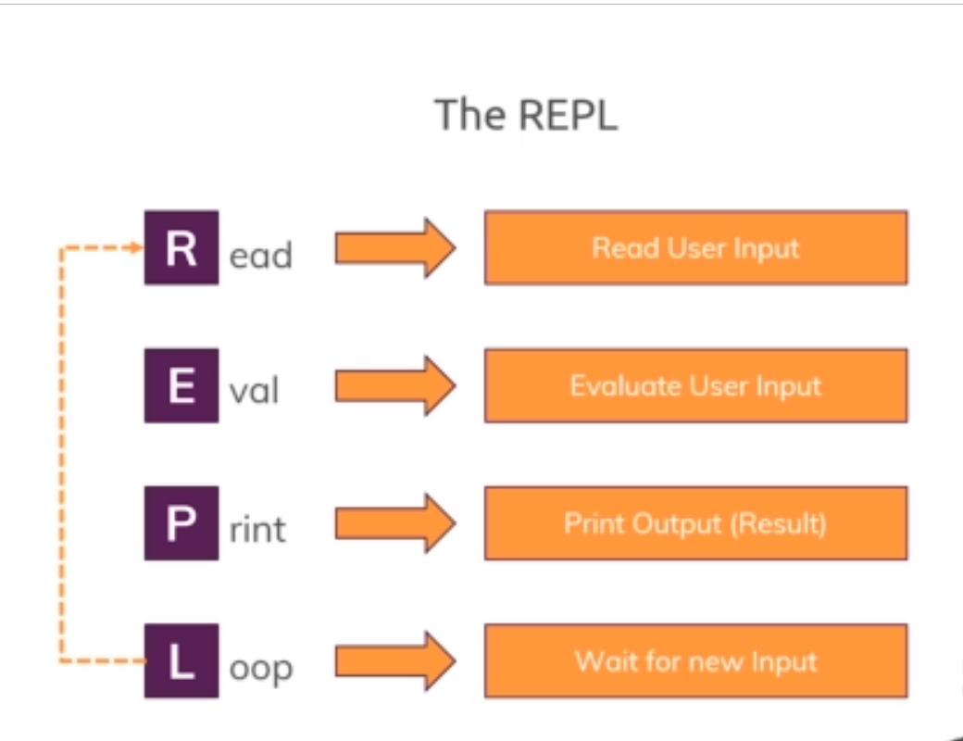

We saw we type node and press enter in cmd, we can execute statements of ndoejs. That is called REPL ode.